
Hello, my name is Trea Jackson. Welcome to my portfolio.
Here, you’ll find everything from writing samples to creative processes and my passion for writing.
My experiences that give me the greatest emotion capture the true essence of storytelling.

Education: Masters, Psychology Degree Roosevelt University
Employment: Illinois Department of Human Services, 2014-

My Writing Journey

The Beginning

I started writing at age seven while in the foster care system. This was how I coped with being in foster care. All of my passions and motivations empowered me to creatively use all of my energy to write incredible stories that opened a door. I got to share my world with others, as many were very curious about the dysfunction before and what happens when you are in foster care lost as a bee that can no longer find its hive. I found the courage to fly away. I created a world of positive energy so that I could be there whenever needed. This was my escape from the dysfunctional world that I was forced to live in. My reality was cruel , but my fantasy world was kindness and love. This gave me the strength to keep going and to survive. These are my experiences, stories, and reflections of my world.

Developing Stories

These are years when I began to write fantasy stories to actually cope with my reality. I love sitting on the grass and looking into the sky to just use my imagination, project and create stories. Not having much but some paper, I would write some stories. These stories went from fantasy to fantasy mixed with a touch of reality. These are the years that my writing developed so much. My life experiences fueled my stories and my ever-changing life. This was both positive and negative. I also found that my experiences which lead to the stories became my escape and coping mechanism. During this time, I never had the ambition to become an author.

Writing the Manuscript

This process took many years to develop into the finished manuscript. There were many moments of writing over and over again, attempting to project while writing the most intriguing story to share with the world. It all started with poems, short stories, and notebooks filled with many stories of suggestions. All of these together became the manuscript one book after the next. All the books are connected together with such powerful emotion that they tell the entire story from start to finish. It took my heart a long time to feel ready to share all these stories that were written in all these composition notebooks. Then once written, I had to let go and force myself to allow permission to finally find peace with opening my heart and to bare my soul. This was very hard for me as a former foster child who lost hope, was frustrated, and didn’t trust people. Now I was about to share everything. I had to find the courage and strength to make this happen. So, this took many years to actually accomplish finding that moment to feel secure enough to do so. The moment I did that was the same moment I let the walls down from around me. I knew then I was ready.

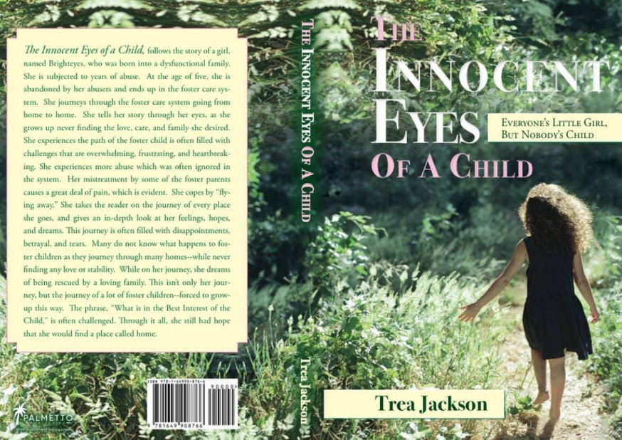
Book Series: Six books
The Innocent Eyes of a Child: Everyone’s Little Girl, But Nobody’s Child (Book One)
Published May 2021
The first book of the book series takes the reader on an emotional journey from a very dysfunctional abusive home. Then will transition the reader as Brighteyes, enters the foster care system. Thus, as this little girl dreams of being rescued from the abuse, she ends up in the everlasting messed up foster care system. From there she journeys through the years from placement to placement, never finding that loving permanent home. The reader will get a glimpse of the anger, frustration, disappointments, and tests of genuine strength of this little girl. This little girl will journey until the end of the book, with a pause as she finds a home, so she thinks. The book is left on a Clif note forcing the reader to use their imagination to figure it out or wait for the next book.

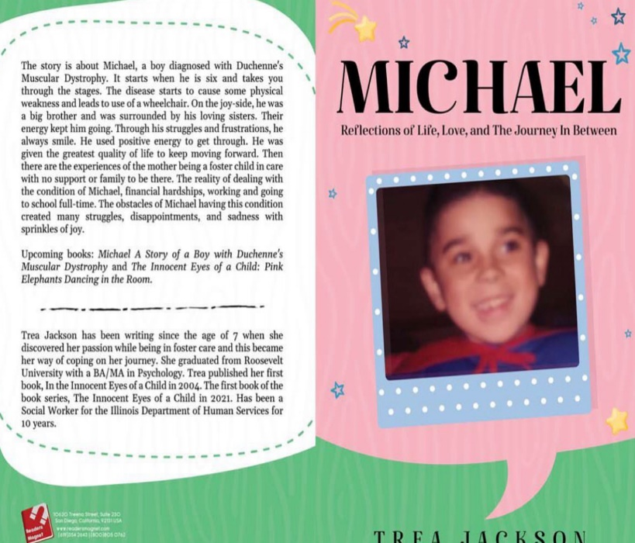

Michael: Reflections of Life, Love, and the Journey In Between (2024)

This follows a boy named Michael from birth until he loses his battle with Muscular Dystrophy in his early teens. The book also opens the door for the reader to not only see Michael and how this condition affects him, but the entire family. This condition completely rewrites the family structure. Nothing can prepare you emotionally without forcing you to deal with the reality of this relentless disease physically. Make a muscle and fight Duchenne’s Muscular Dystrophy. This unique book is the first novel of its kind to not only talk about the condition, but to talk about the journey in between having the condition. In addition, how does this affect the family?

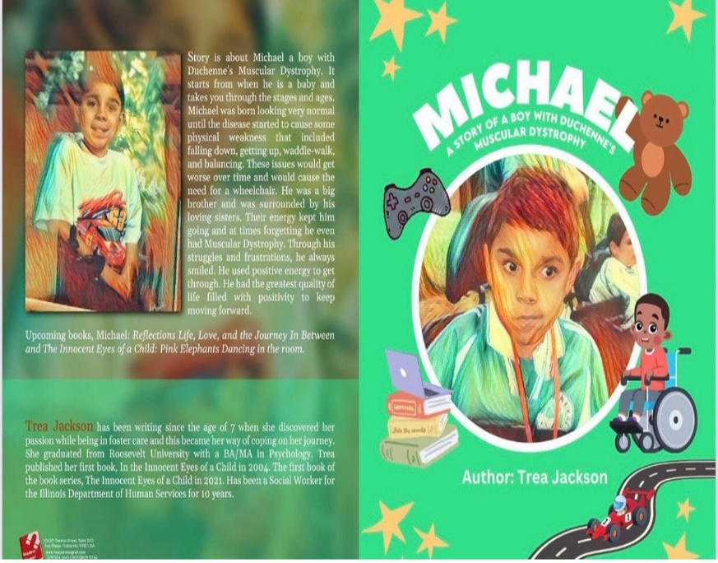

Children’s book
Michael: A Story of a Boy with Duchenne’s Muscular Dystrophy (2024)

This is the short version of the novel for children. This was to honor my son Michael by sharing his life, legacy, and pieces of his life that brought him great joy until he departed from this world. “He may be gone physically from this world, but spiritually he has never left.”

Book Reviews

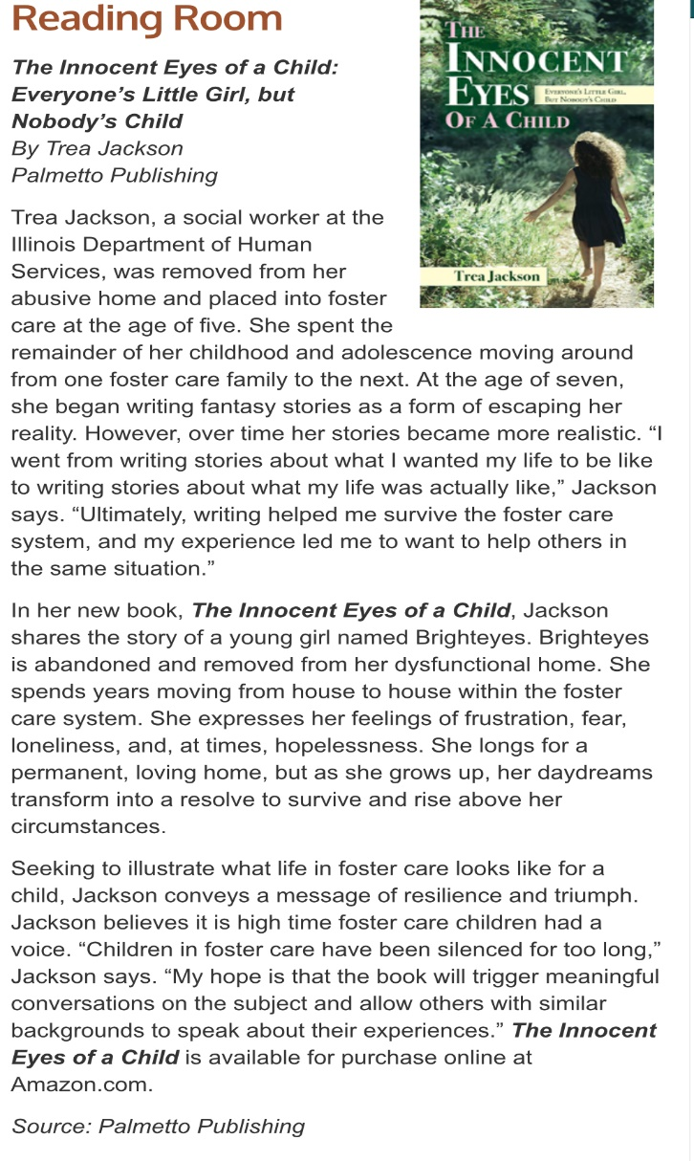

https://www.readersmagnet.biz/readersmagnet-review-the-innocent-eyes-of-a-child-by-trea-jackson/

Upcoming books The Innocent Eyes of a Child book series

Book 2: Pink Elephants Dancing in the Room
Book 3: Little Girl Lost
Book 4: Flyaway
Book 5: Lost In the System
Book 6: Reflections: The Aftermath of Surviving the Foster Youth Care System

